**SUPERIOR UNIVERSITY LAHORE**



**COMPUTER NETWORKS LAB**

**NAME:**

**AAMINA QASIM**

**ROLL NO.:**

**SU92-BSDSM-F22-027**

**PROGRAM:**

**BS DATA SCIENCE**

**SECTION:**

**5-A**

**COURSE:**

**COMPUTER NETWORKS LAB**

**SUBMITTED TO:**

**SIR RASIKH ALI**

**Documentation for Government Agency Network Infrastructure**

* **Project Title**: Government Agency Network Infrastructure
* **Tool Used**: Cisco Packet Tracer
* **Prepared By**: Aamina Qasim
* **Date**: 12/10/2024

**Abstract:**

This report presents a comprehensive overview of the Government Agency Network Design, executed through Cisco Packet Tracer, aiming to facilitate the expansion of a trading floor support center into a new facility. The primary goals of this project are centered around formulating and executing a robust, scalable, and forward-looking network infrastructure. The hierarchical model has been employed, integrating redundancy measures at each layer for enhanced reliability. Key features include the incorporation of dual Internet Service Providers (ISPs) to ensure uninterrupted internet connectivity, establishment of wireless networks for individual departments, creation of distinct VLANs and subnets, and the implementation of Open Shortest Path First (OSPF) for routing. Configuration specifics encompass the setup of DHCP servers, assignment of static IP addresses, implementation of Secure Shell (SSH) for secure access, and Port Address Translation (PAT) for managing outbound connections. The report underscores the significance of rigorous testing and verification processes, ensuring the successful deployment of a resilient network infrastructure that not only fulfills existing business requirements but also strategically positions the organization for future technological advancements and expansion

Table of Contents Abstract...................................................................................................................................................2 1. Introduction ........................................................................................................................................4 2. Network Design...................................................................................................................................5 3. Routing Configuration.........................................................................................................................8 4. Switching Configuration....................................................................................................................11 5. Inter-VLAN Routing ...........................................................................................................................13 6. Testing and Validation ......................................................................................................................17 10. Results and Evaluation....................................................................................................................19 11. Conclusion.......................................................................................................................................20 12. Future Work....................................................................................................................................20 13. References.......................................................................................................................................21 14. Appendices......................................................................................................................................21

**Introduction**

**Background:**

"Government Agency Network Design" This project concentrates on navigating the intricacies inherent in developing an efficient and forward-looking network, leveraging Cisco Packet Tracer. The endeavour closely aligns with the specific requirements and expansion strategies of the trading floor support center. The primary objectives of the "Government Agency Network Design" initiative are clearly outlined to cater to the unique demands of the company's network infrastructure. The project aims to establish a hierarchical network model incorporating redundancy measures at every layer. It seeks to establish connections with a minimum of two Internet Service Providers (ISPs) to enhance internet reliability, deploy wireless networks tailored for specific departments, allocate distinct Virtual Local Area Networks (VLANs) and subnets to ensure secure communication, and configure routing protocols, security protocols, and advanced functionalities like Port Address Translation (PAT). By achieving these objectives, the project aims to develop a scalable, resilient, and forward-looking network infrastructure that not only fulfils current operational needs but also anticipates and accommodates the future growth and technological advancements of the company.

**Network Design:**

**Topology:**

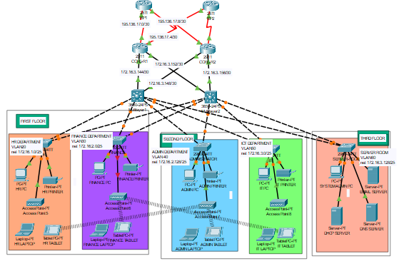

**Components:**

The network design for the project incorporates the following devices:

**1. Routers (4):**

o 2 ISP router for upstream connectivity.

o Positioned at the core layer for redundancy.

o Connect to both ISPs for internet connectivity.

o Configured with static, public IP addresses from ISPs.

**2. Multilayer Switches (2):**

o Deployed at the core layer to provide redundancy and efficient routing.

o Configured for both switching and routing functionalities.

o Assigned IP addresses to enable inter-VLAN routing. 3. Distribution Layer Switches (Multiple):

o Connect individual departments to the core layer. o Facilitate communication within respective VLANs.

**4. End-User Devices (PCs):**

o Deployed at the access layer.

o Connected to distribution layer switches for departmental access.

**6. DHCP Servers (1):**

**o** Located in the server room.

o Dynamically allocate IP addresses to end-user devices.

**7. Server Room Devices (Servers, etc.):**

o DNS server, HTTP server etc.

o Devices in the server room are allocated static IP addresses.

o These devices may include servers, storage units, and networking equipment.

These devices collectively form a structured and well-organized network architecture, integrating redundancy, efficient routing, and secure communication to meet the specific requirements of the trading floor support center's operations.

IP Addressing Scheme Provide details about the IP addressing scheme applied to the network. Base Network: 192.168.0.0/22

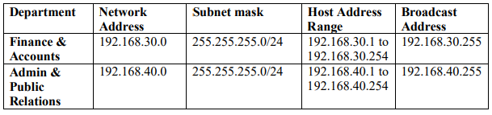

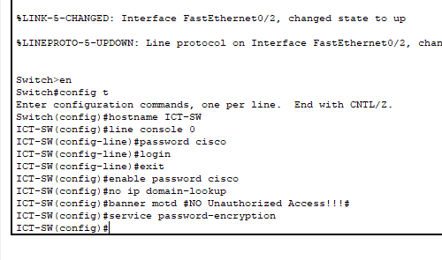



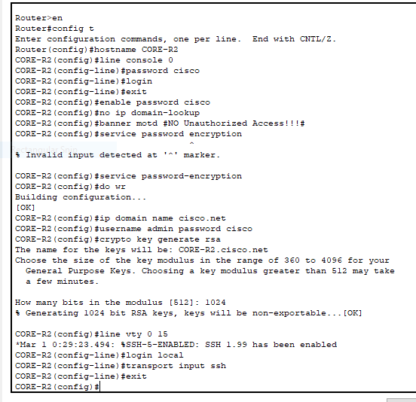

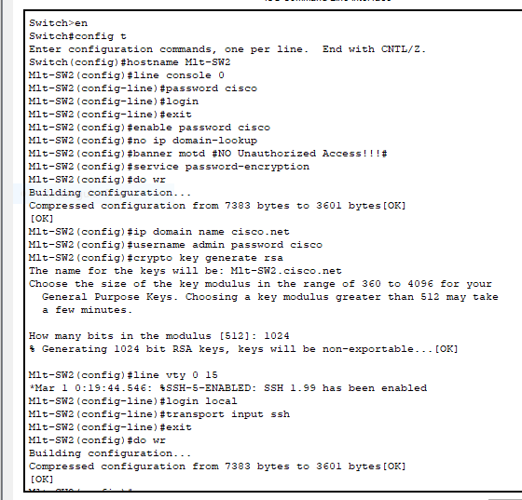

**Testing and Validation:**

**Simulation:**

Packet Tracer was utilized to simulate and test the designed network. Packet Tracer is a network simulation tool that provides a virtual environment for designing, configuring, and testing network scenarios.

The simulation process involves:

• Network Topology Design: The network topology, including routers, switches, PCs, servers, and other devices, was designed within Packet Tracer based on the specified requirements.

• Configuration Implementation: Using the designed topology, configurations were implemented on routers, switches, and other network devices according to the provided guidelines. Cisco Packet Tracer allows users to configure devices with a user-friendly interface similar to actual Cisco devices.

• Traffic Simulation: Packet Tracer allows the simulation of network traffic and communication between devices. This involves generating traffic, testing connectivity, and ensuring that data flows as expected.

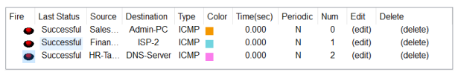

**Summary:**

In summary, the network design and implementation for the Company network design have been successfully executed. Key achievements include a hierarchical network model with redundancy at multiple layers, departmental segmentation through VLANs, inter-VLAN routing. Thorough testing using Cisco Packet Tracer ensured proper functionality and alignment with project requirements. The resulting network provides scalability, security, and efficiency, meeting the specified needs of the organization.

**References [1]:**

C. N. Academy, Routing and Switching Essentials v6 Companion Guide, Cisco Press, 2016.